Pharmacy Service System

User Manual

Bereket Degefa

Eastern Kentucky University CSC 340 Ethics & Software Engineering, Dr. Chang, 12/13/2018

# User’s Manual

Contents

User’s Manual 1

1. General Information 1

a. System Overview 2

1. Getting Started 2

a. Installation 2

b. Setting Up 2

2. Logging In 3

3. System Menu 4

4. Change User ID and Password 4

5. Report System 4

## General Information

This Application implements a system that allows a pharmacy to provide basic services to its patients. This system is a part of the doctor-patient system in a team project done not long ago. The three subsystems should work together to provide doctors, patients, and pharmacies better services.

### System Overview

This pharmacy service system should be able to connect to the doctor-patient system. It will receive new prescriptions from doctors, receive refill requests from patients, check the basic information of patients (including their drug allergy record), display the status of a specified prescription/refill, and send a notice to a patient when his/her medicine is ready, and send/receive a notice to discuss a case with doctors.

## Getting Started

### Installation

To install this application first you need all you need to do is simply to run the executable file called “Pharmacy service system”

### Setting Up

First you need to open the application “**Pharmacy Service System”,** Once prompted login using your credential. If in any situation, the application fails to run, or gives you an error please refer to Report System Page.

## Logging In

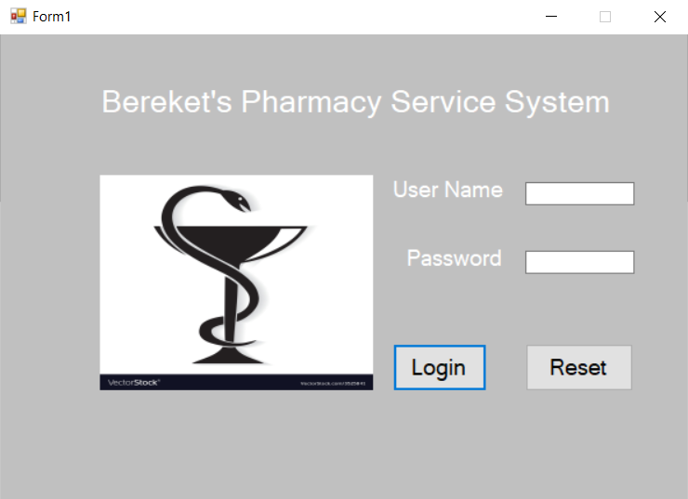

**Input your user name and password!**

## System Menu

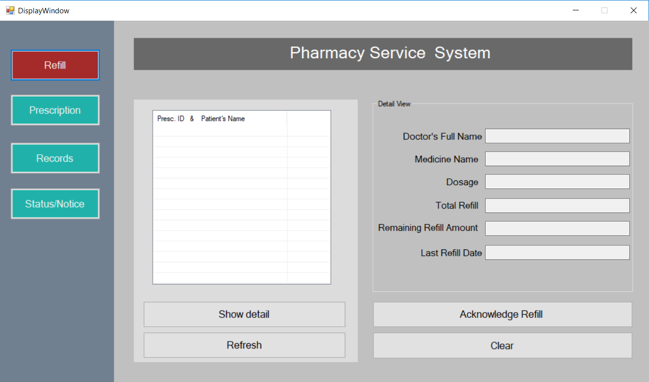

**After successfully logging to the system, this window will be displayed from which you are able to navigate to the task of your choice!**

## Change User ID and Password

! Currently this version of the system doesn’t have the capability of changing user name and password. For now, please contact the developer team and they will sort you right away.

## Report System

Please contact the developer team if you are unable to resolve the issue by yourself. Also, if you need a password reset or new user account.

Name: Dev. Developers and consultant

Address: Richmond, Kentucky

Phone: XXX-XXX-XXXX